Student B
Aron Ralston
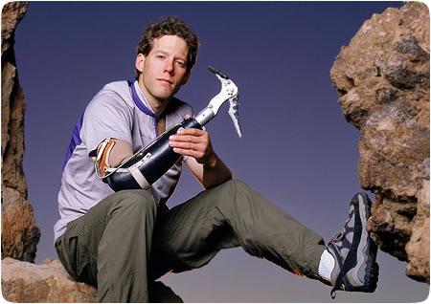
Ask questions about the blanks after the even numbers,
e.g. (2): “When did the accident happen?”

Aron Ralston was born on (1) October 27th, 1975, in Indianapolis.

(2)_____________________, Ralston was hiking through Blue John Canyon, Utah. While descending a slot canyon, a suspended boulder from which he was climbing down became dislodged, crushing his right hand and pinning it against the (3) canyon wall. (4)__________ ______________________, thus no one would be searching for him.

Assuming that he would die he spent (5) five days slowly sipping his small amount of remaining water and slowly digesting his small amount of food while trying to extricate* his arm. His efforts were futile as he could not free his arm from (6)_________________. After three days of trying to lift and break the boulder, the dehydrated and delirious Ralston prepared to amputate his trapped right arm at a point on the mid-forearm. He made some exploratory superficial cuts to his (7) forearm in the first few days. On the fourth day he realized that in order to free his arm he would have to cut through the bones in it, but the tools he had available were (8)_____________ to do so.

When he ran out of food and water on the fifth day, he carved his name, (9) date of birth and presumed date of death into the sandstone canyon wall, and videotaped his last (10)___________ to his family. He did not expect to survive the night. After waking at dawn the following day he had an epiphany** that he could break his radius and ulna bones using torque against his trapped arm. He did so, and then performed the (11) amputation, which took about (12)____________ with his multi-tool, which included a dull two-inch knife.

After freeing himself, Ralston still had to get back to his car. He climbed out of the slot canyon in which he had been trapped, rappelled down a (13) 20 m wall one-handed,
then hiked out of the canyon in the hot midday sun. While hiking out, he encountered a family on vacation from (14)______________ who gave him food and water and then hurried to alert the authorities.

In August 2009, Ralston married (15) Jessica Trusty. His first child, Leo, was born in February 2010. The family resides in (16)__________________. Ralston still enjoys canyoneering and mountaineering.

*extricate = to free something from difficulties
**epiphany = a grasp of reality; a sudden realization or discovery

Date:_________Name:______________________________Class:___________

Write your questions below:

2.) ____________________________________________________
________________________________________________________
4.) ____________________________________________________
________________________________________________________
6.) ____________________________________________________
________________________________________________________
8.) ____________________________________________________
________________________________________________________
10.) ____________________________________________________
________________________________________________________
12.) ____________________________________________________
________________________________________________________
14.) ____________________________________________________
________________________________________________________16.) ____________________________________________________
________________________________________________________

