Student A
Aron Ralston
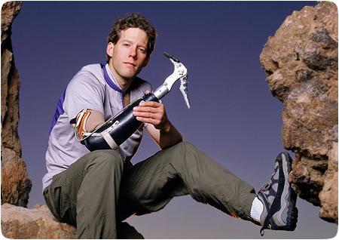
Ask questions about the blanks after the odd numbers,
e.g. (1): “What date was he born on?”

Aron Ralston was born on (1)___________________, in Indianapolis.

(2) On April 26th, 2003, Ralston was hiking through Blue John Canyon, Utah. While descending a slot canyon, a suspended boulder from which he was climbing down became dislodged, crushing his right hand and pinning it against the (3)_____________. (4) Ralston had not told anybody of his hiking plans, thus no one would be searching for him.

Assuming that he would die he spent (5)______________ slowly sipping his small amount of remaining water and slowly digesting his small amount of food while trying to extricate* his arm. His efforts were futile as he could not free his arm from (6) the 360 kg boulder. After three days of trying to lift and break the boulder, the dehydrated and delirious Ralston prepared to amputate his trapped right arm at a point on the mid-forearm. He made some exploratory superficial cuts to his (7)_________ in the first few days. On the fourth day he realized that in order to free his arm he would have to cut through the bones in it, but the tools he had available were (8) insufficient to do so.

When he ran out of food and water on the fifth day, he carved his name, (9)_____________ and presumed date of death into the sandstone canyon wall, and videotaped his last
(10) goodbyes to his family. He did not expect to survive the night. After waking at dawn the following day he had an epiphany** that he could break his radius and ulna bones using torque against his trapped arm. He did so, and then performed the (11)___________, which took about (12) one hour with his multi-tool, which included a dull two-inch knife.

After freeing himself, Ralston still had to get back to his car. He climbed out of the slot canyon in which he had been trapped, rappelled down a (13)_____ wall one-handed, then hiked out of the canyon in the hot midday sun. While hiking out, he encountered a family on vacation from (14) the Netherlands who gave him food and water and then hurried to alert the authorities.

In August 2009, Ralston married (15)____________. His first child, Leo, was born in February 2010. The family resides in (16) Boulder, Colorado. Ralston still enjoys canyoneering and mountaineering.

*extricate = to free something from difficulties
**epiphany = a grasp of reality; a sudden realization or discovery

Date:_________Name:______________________________Class:___________

Write your questions below:

1.) ____________________________________________________
________________________________________________________
3.) ____________________________________________________
________________________________________________________
5.) ____________________________________________________
________________________________________________________
7.) ____________________________________________________
________________________________________________________
9.) ____________________________________________________
________________________________________________________
11.) ____________________________________________________
________________________________________________________
13.) ____________________________________________________
________________________________________________________15.) ____________________________________________________
________________________________________________________

