Date__________Name:___________________________________________Class:_________

127 Hours movie worksheet.
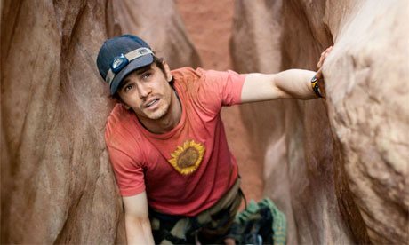
1.
Put the following into correct order as they appeared in the movie. Write in the box 1 for first, 2 for second, etc.

Aron rapels one handed down a 20m wall and then falls into a pool of water.

It’s a sunny morning. Aron is cycling carefree through the canyon lands. He crashes his bike and takes a photo of himself.

Thinking he will die, Aron videotapes his last goodbye to his family.

While trapped in the canyon, Aron checks his supplies which include a camera, a video camera, a multitool, some water and a small amount of food.

Aron breaks the bone in his forearm and then amputates his arm using the knife on his multitool. It takes him about an hour.

While descending a canyon, a boulder becomes dislodged and pins Aron’s arm against the canyon wall. Aron tries to move the boulder but is unable to do so.

Aron carves his name, date of birth and presumed date of death in to the canyon wall.

It’s night and Aron is driving out of the city to the canyon lands. Aron is excited about his trip and he is listening to loud music.

Aron meets Megan and kristen and offers to be their guide. He takes them into a canyon where they free fall into a pool of water below.

2.
Vocabulary and phrases from the movie.
Match the word or phrase in column A to the correct meaning in column B.

 | A |  |  | B
1 | “This is insane.” |  | A | Stupid or incompetent people.
2 | “Dorks!” |  | B | To see things that are not really there.
3 | “Rock on!” |  | C | A road, path or way to get from one place to another.
4 | “Don’t lose it.” |  | D | To describe a place where you spend a lot of your free time.
5 | Hallucinate |  | E | To make something longer.
6 | Stretch |  | F | Aron finds it hard to believe the situation he is in and shouts this over and over.
7 | “This is my second home.” |  | G | A wheel turned by a belt or rope.
8 | Route |  | H | An encouraging or positive exclamation.
9 | Guidebook |  | I | A handbook with information about a place for visitors.
10 | Pulley |  | J | Aron tells himself this in order to keep himself calm.

3. How did Arons life change after the incident? Complete the sentences below.
What has he got now?
He has___________________________________________________________
_________________________________________________________________
What does he still do?
He still___________________________________________________________
_________________________________________________________________
What does he always do now?
He always________________________________________________________
_________________________________________________________________

4. What word best describes the feelings Aron had in each Scene?

- Aron realises he is trapped and is unable to move the boulder. He begins to panic.

Dispair Comfort Sentiment

- Aron walks free from the canyon and feels warm sunlight on his face.

Anguish Joy Relief

- It’s a sunny moring and Aron is cycling carefree through the canyon lands.

Excitement Worry Sentiment

- Aron is alone in the canyon and thinking about his friends, family and a past girlfriend.

Joy Desperation Loneliness

- Aron is thinking about a bottle of Gatorade in his truck.

Hunger Thirst Desire

